

**Alpha Phi Alpha Educational Scholarship Foundation, Inc.**

**Delta Delta Lambda Chapter of Alpha Phi Alpha Fraternity, Inc.**

**2024-2025 Grant and Scholarship Application**

**Dear Applicant:**

Thank you for your interest in the Alpha Phi Alpha Educational Foundation Scholarship. To be eligible for this scholarship, you must meet the prerequisites and complete the guidelines contained in this application. All applications must be completed by May 1, 2025.

**Prerequisites:**

1. A high school graduate of the 2024-2025 academic year
2. Intend to use funds towards education at an accredited institution of higher learning

**Guidelines:**

1. Complete the attached application.
2. A resume listing supporting scholastic and academic honors (awards, prizes, etc.), extra-curricular activities, community/volunteer experience(s), and employment (if any).
3. Letter of Interest: single spaced, not to exceed two pages, stating your interests, describing your character, supporting acts of kindness/community service, and/or religious activities you currently participate in. Describe your plans for the future, and why/how you feel

African Americans are influencing our society.

1. Two (2) letters of recommendation.
2. An official high school transcript (must be in sealed envelope).

**Procedure:**

1. Complete the entire application as listed in guideline section.
2. Type or print neatly in black or blue ink.
3. Provide accurate and current information.
4. Mail completed application to:

Delta Delta Lambda Chapter

P.O. Box 866

West Palm Beach, FL 33401

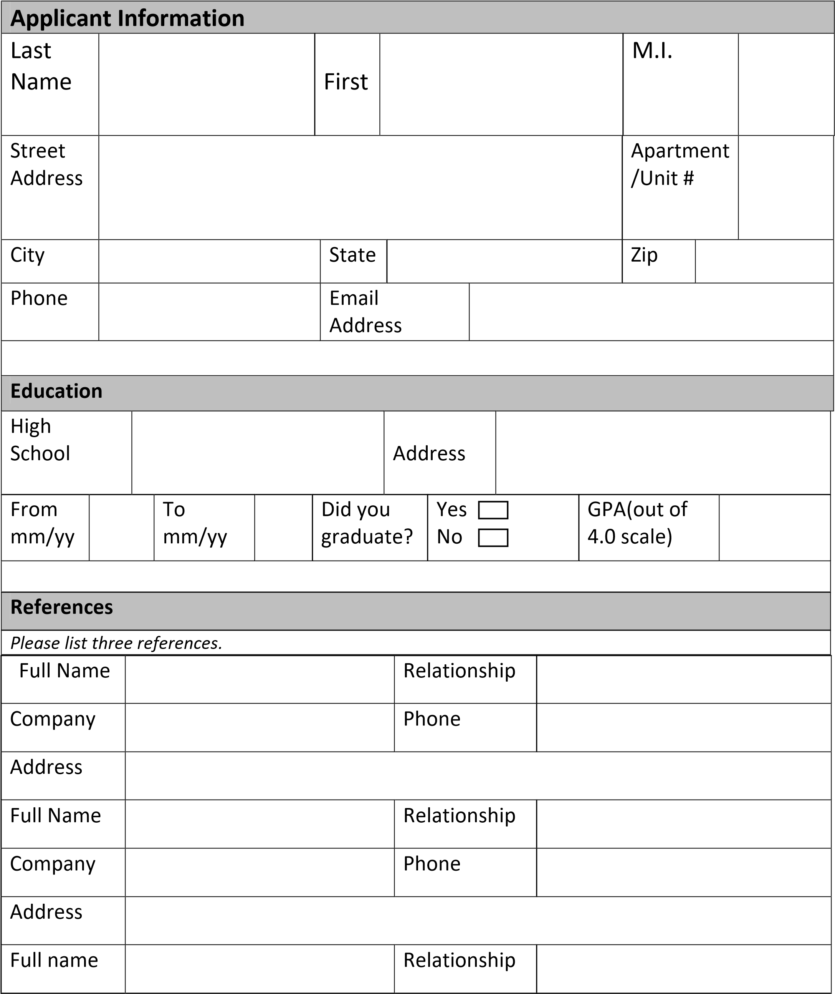

|  |  |  |  |
| --- | --- | --- | --- |
| Company |  | Phone |  |
| Address |  | | |
| **Disclaimer and Signature** | | | |
| I certify that my answers are true and complete to the best of my knowledge.  If this application leads to a scholarship award or grant, I understand that false or misleading information on my application or interview may result in disqualification. | | | |
| Signature Date | | | |